Amey Kelekar

[INFO6350](https://blackboard.neu.edu/webapps/blackboard/execute/launcher?type=Course&id=_2455988_1&url=)

Assignment 4

02/21/2016

1. **Flow of the assignment:**

Hospital ----> List of Departments

Department ----> List of Patients

Person ----> address

Patient extends Person, Person ----> Medical record

1. **Functionalities:**
2. A/a -- Create and add a patient to specific department
3. S/s -- Search a patient in the entire hospital
4. L/l -- List of patients
5. List patients as per department
6. List all patients
7. E/e -- Exit the application
8. Output Screen shots:

Adding a new patient



Search a patient:

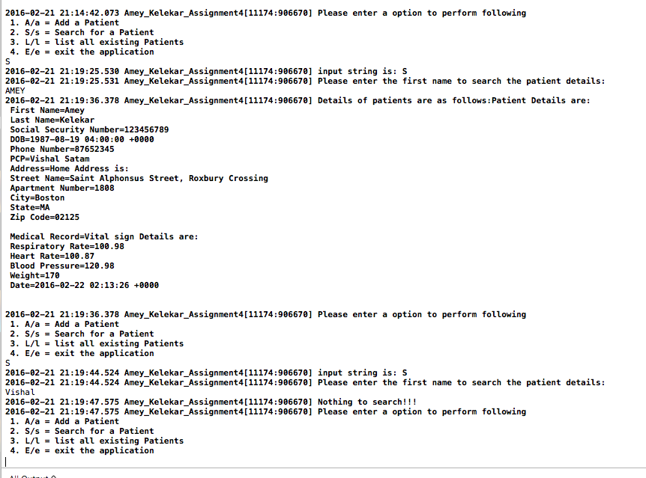

List a patient:



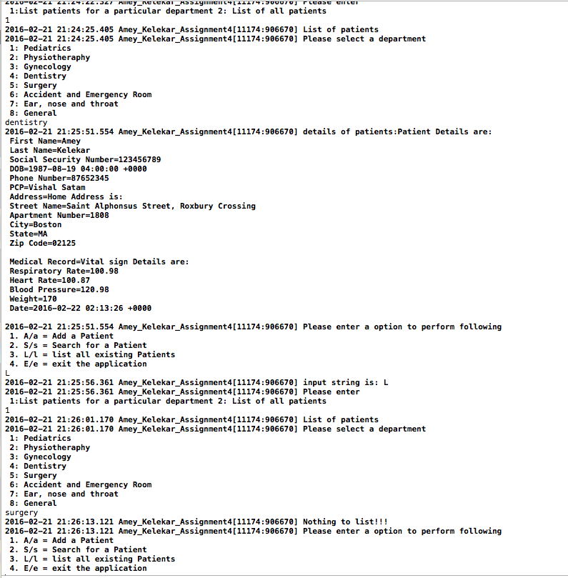

Exit the application:

